|  |
| --- |
| **Diamond Ring** |

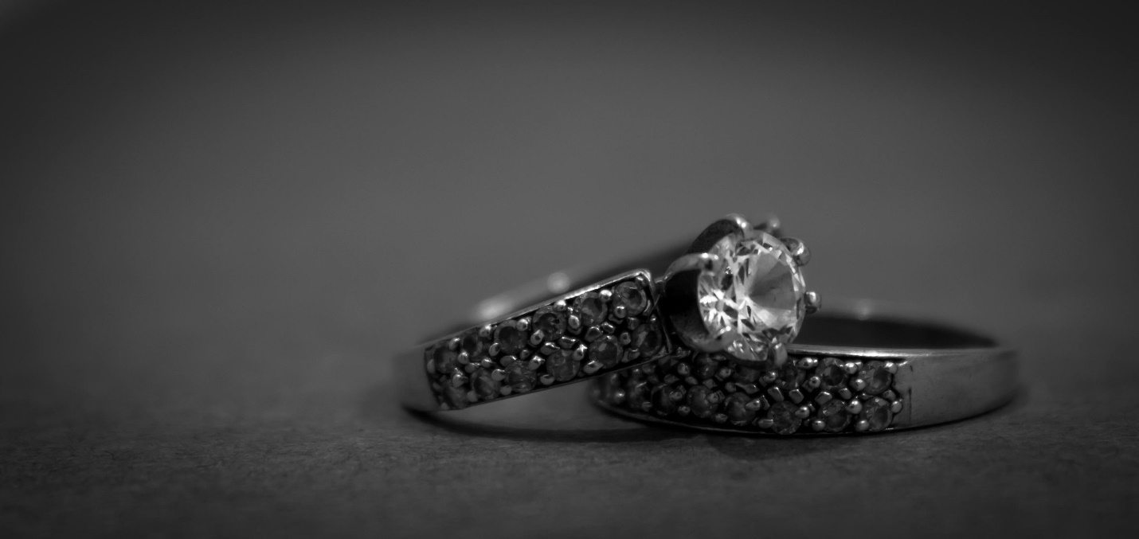

Refers to how the diamond has been shaped and faceted. Common shapes include **round, princess, emerald, oval, marquise, cushion, pear, and Asscher**. A well-cut diamond will have more sparkle and shine due to how it reflects light.